ServiceNow Certified Application Developer

Project Title

Employee Raise Issues-Record Producer & Service Portal Integration Guide

Name : Bachhanaboyina Renuka
College : Chalapathi Institute of Engineering and technology
Email : y23cse007@chalapathi.engg.ac.in

Project overview
The Employee Raise Issues project is designed to provide a simple and organized platform for employees to report workplace issues, concerns, or requests. Employees can submit an issue by providing details such as the issue title, description, category, priority, and required attachments.
After an issue is submitted, the system creates a unique issue record and forwards it to the appropriate Manager or HR team for review and action. The concerned team can update the issue status, communicate the resolution, and track the issue until it is closed.

Table of Contents
1. Introduction
2. Project Objectives
3. Key Features
4. ServiceNow Developer Setup
5. Project Implementation in ServiceNow
6. Screenshots of Output
7. Conclusion

- Introduction
The Employee Raise Issue – Record Producer & Service Portal Integration project provides a simple and user-friendly way for employees to report workplace issues through a Service Portal. Instead of accessing backend tables or complex forms, employees can use the portal to submit their issues easily.
A Record Producer is used to create an employee issue record from the information entered through the portal. Employees can provide details such as the issue title, description, category, priority, and other required information. After submission, the system automatically creates a record in the Employee Raise Issue table.
The Service Portal provides the user interface through which employees can access and submit the issue form. The integration between the Record Producer and Service Portal connects the employee-facing portal with the backend issue-management table.
This project helps organizations maintain a centralized, organized, and trackable process for handling employee issues. It also reduces manual work and makes it easier for employees and management to monitor the progress of reported issues.
- Project Objective
The main objective of the Employee Raise Issue – Record Producer & Service Portal Integration project is to develop a structured and user-friendly system for managing employee-raised issues. The project aims to simplify issue submission, improve issue tracking, and ensure that employee issues are directed to the appropriate team for review and resolution.
The main objectives of the Employee Raise Issue – Record Producer & Service Portal Integration project are:

- Easy Issue Reporting – Provide employees with a simple Service Portal to raise workplace issues.
- Record Creation – Use a Record Producer to automatically create an Employee Raise Issue record when an employee submits the form.
- Centralized Management – Store all employee issues in a centralized system for easy management and tracking.
- Reduce Manual Work – Minimize manual data entry and reduce the need for emails or verbal reporting.
- Issue Tracking – Allow employees and responsible teams to track the status and progress of submitted issues.
- Proper Assignment – Help route issues to the appropriate Manager or HR team for review and action.
- Improve Transparency – Provide clear information about issue status, updates, and resolution.
- Maintain Records – Keep a structured history of employee issues, actions taken, and resolutions for future reference.

3.Key features
- Service Portal Interface – Provides a simple and user-friendly portal for employees to raise issues.
- Record Producer – Allows employees to submit an issue form and automatically creates a record in the Employee Raise Issue table.
- Employee Issue Submission – Employees can enter details such as issue title, description, category, priority, and attachments.
- Automatic Record Creation – Submitted information is automatically stored as an issue record with a unique issue number.
- Issue Categorization – Issues can be categorized based on their type for easier management.
- Issue Assignment – Submitted issues can be assigned to the appropriate Manager or HR team.
- Issue Status Tracking – Employees and responsible teams can track the current status of an issue.
- Manager/HR Review – Managers or HR can review submitted issues and take appropriate action.
- Notifications – Users can receive updates about issue submission, status changes, and resolution.
4.ServiceNow Developer Setup:
Access the ServiceNow Developer Portal

1.Go to the ServiceNow Developer Portal(https://developer.servicenow.com/dev.do).
Create a free developer account by selecting Sign Up and providing the required details.
2. After registration, a verification email will be sent to your registered email address. Open the email and complete the verification process.
After successful verification, the ServiceNow Developer Portal Home Page will be displayed.

3. From the Developer Portal, select Start Building or the option to request a Personal Developer Instance (PDI).
The PDI provides a separate ServiceNow environment where you can develop and test your Employee Raise Issue – Record Producer & Service Portal Integration project.

4.After the PDI is provisioned, open the instance using the Open Instance option. Log in using your ServiceNow developer credentials.

5. Click the Profile Icon in the top-right corner to manage your account, view your developer profile, and access available instance-related options.

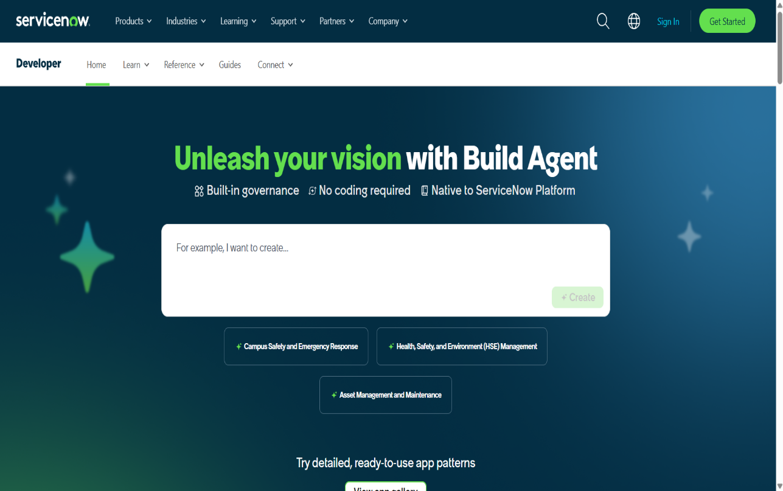
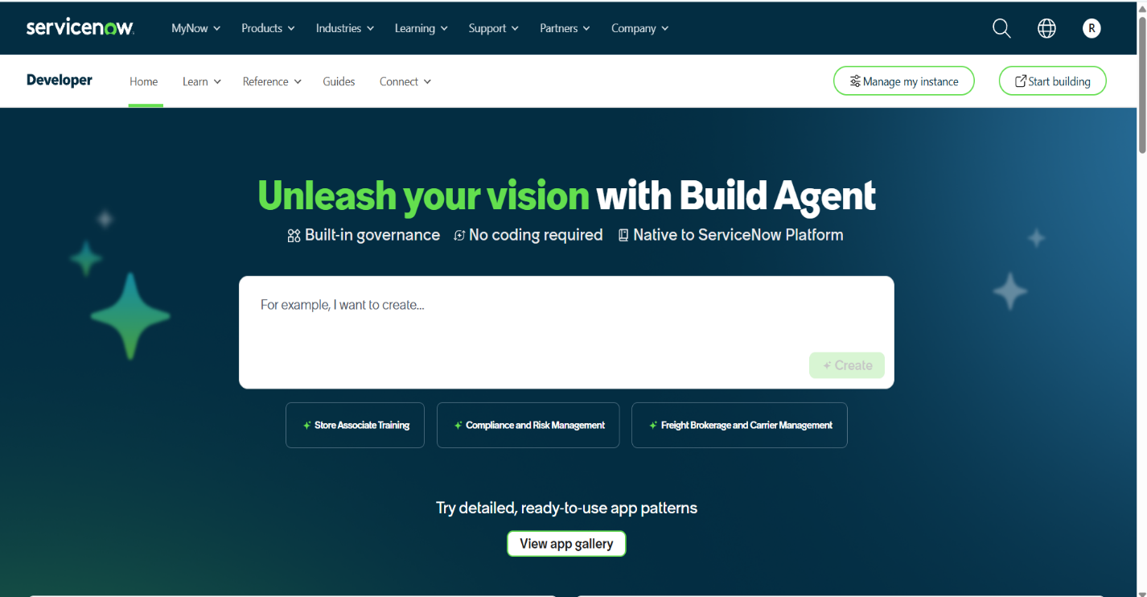

5.Implementation in ServiceNow
After the instance building is completed, the page will be directed into your Creator Studio.
The Employee Raise Issue project is implemented in ServiceNow using a custom table, Record Producer, and Service Portal. The implementation provides employees with a simple way to submit and track their workplace issues.
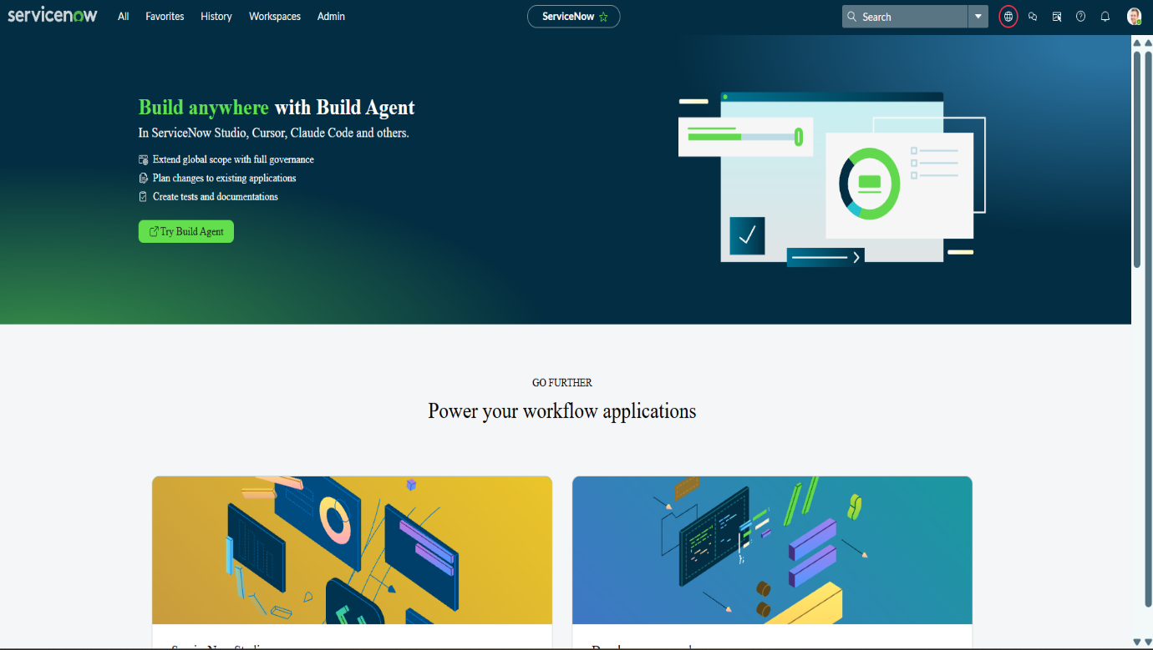
a. Create a Custom Application
The first step in implementing the Employee Raise Issue Management in ServiceNow project is to create a custom application. The custom application Provides a separate environment to develop and manage all the components required for the project.
- Navigate to Application navigator
1. Click on All → App Engine → ServiceNow Studio.
2. Click the Create button and select App to create a new application.
3. Enter the application name as Employee Raise Issue.
4. Select Scoped as the application scope.
5. Click Continue to create the application.
6. After the application is created, return to the ServiceNow home page.
7. Reload/refresh the page. The newly created Employee Raise Issue application will appear as the current application.
8. Open the application to continue configuring the Employee Raise Issue table, Record Producer, variables, and Service Portal integration Guide.

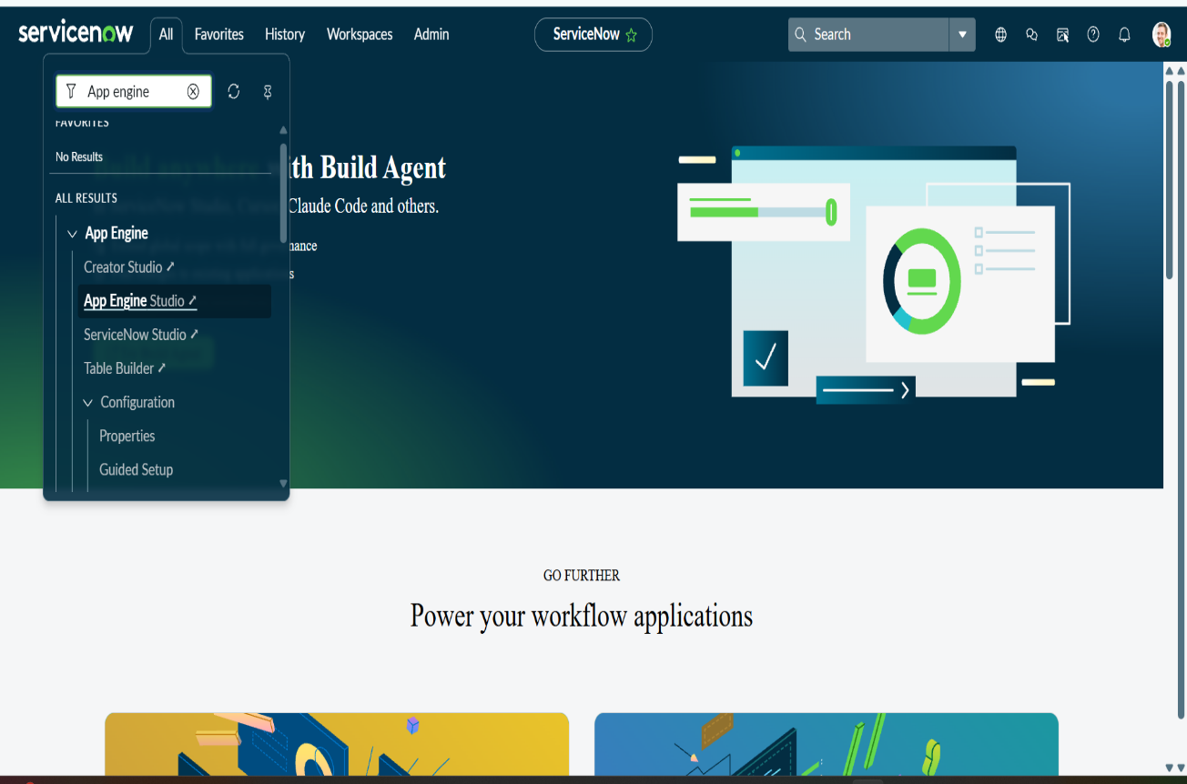

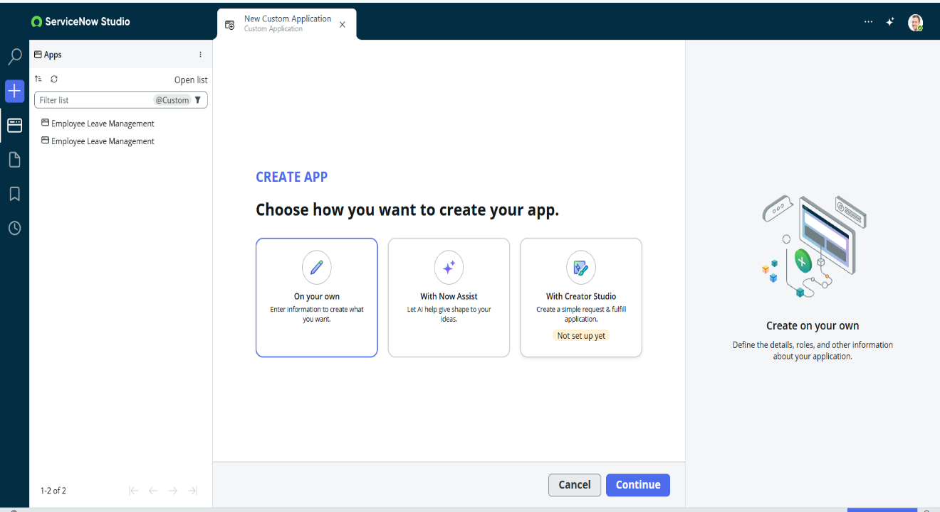

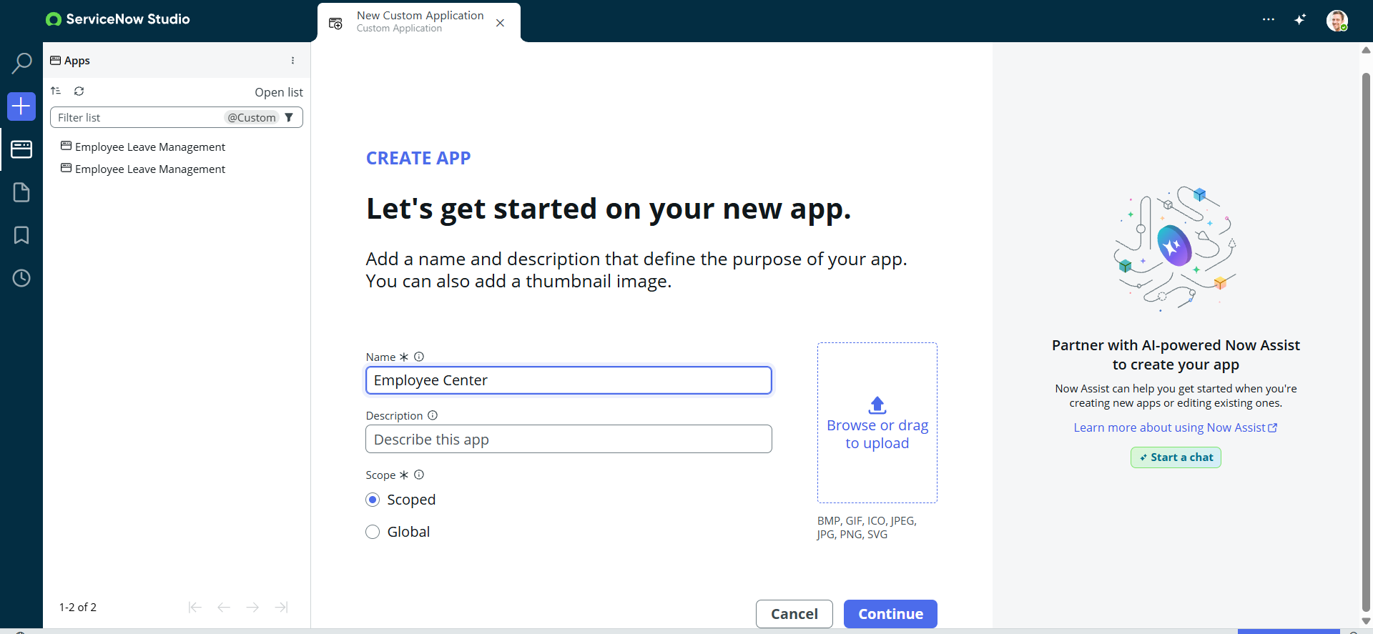
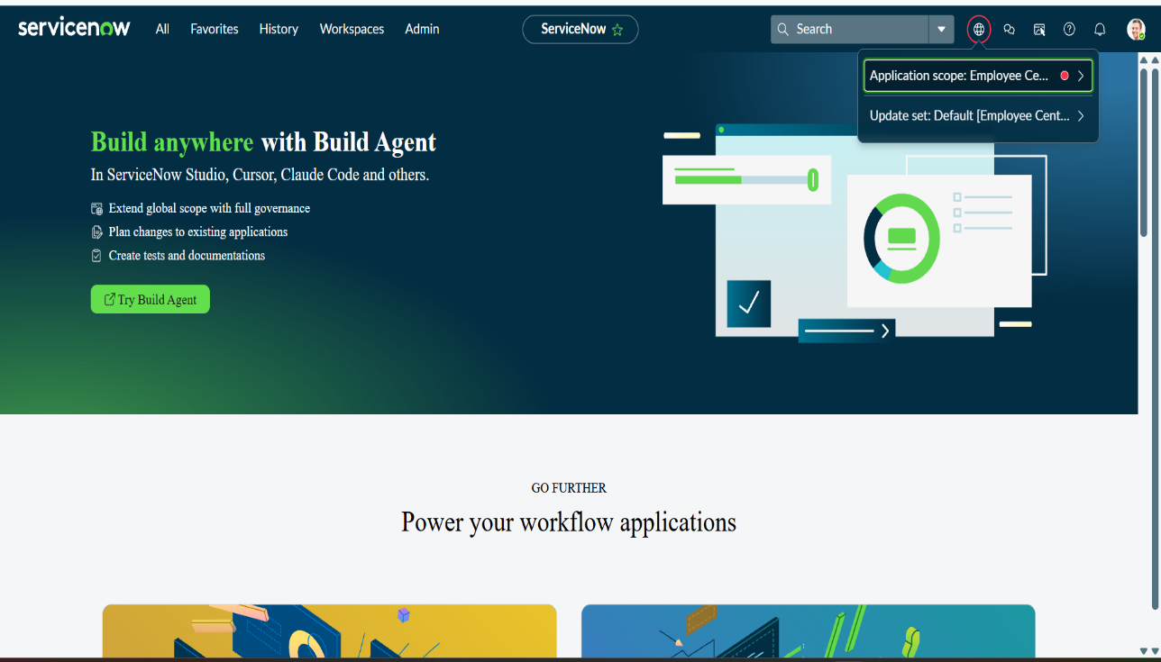

b. Creating a Custom Table and Fields
After creating the Employee Centre custom application, the next step is to create a custom table for storing and managing employee-raised issue records.

1. Navigate to All → System Definition → Tables.
2. Click the New button in the top-right corner to create a new table.
3. In the Label field, enter Employee Raise Issue.
4. The Name field will be automatically generated based on the table label.
5. Under the Controls section, enable Auto-number to automatically generate a unique number for each employee issue.
6. Save the table using the Submit/Save option available in the form or context menu.
7. After saving, the Employee Raise Issue table will be available for adding fields and configuring the issue-management process.
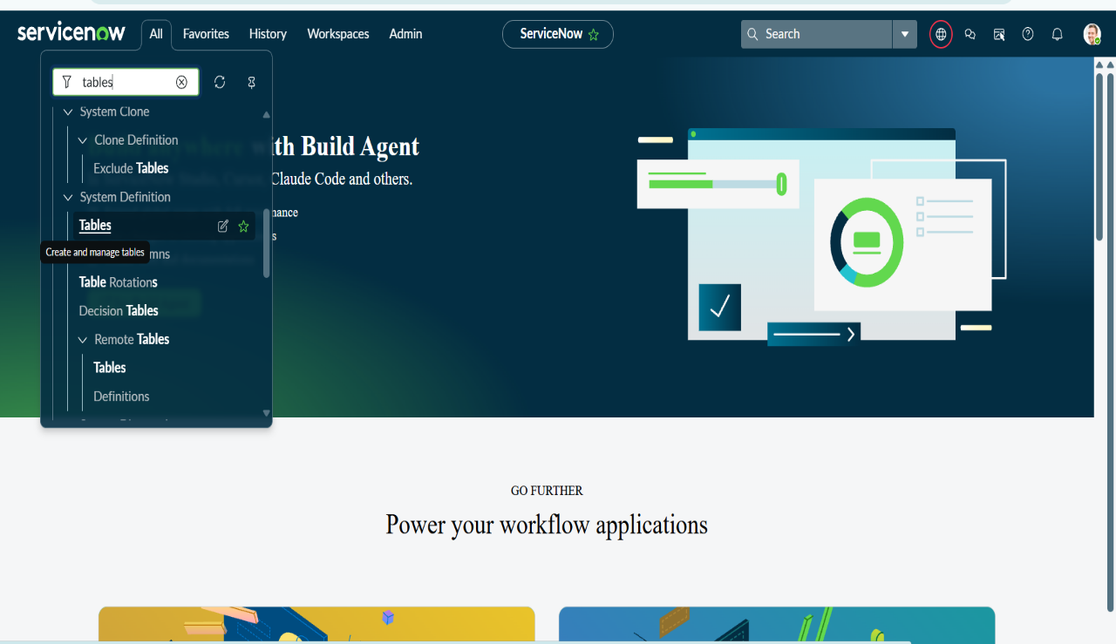

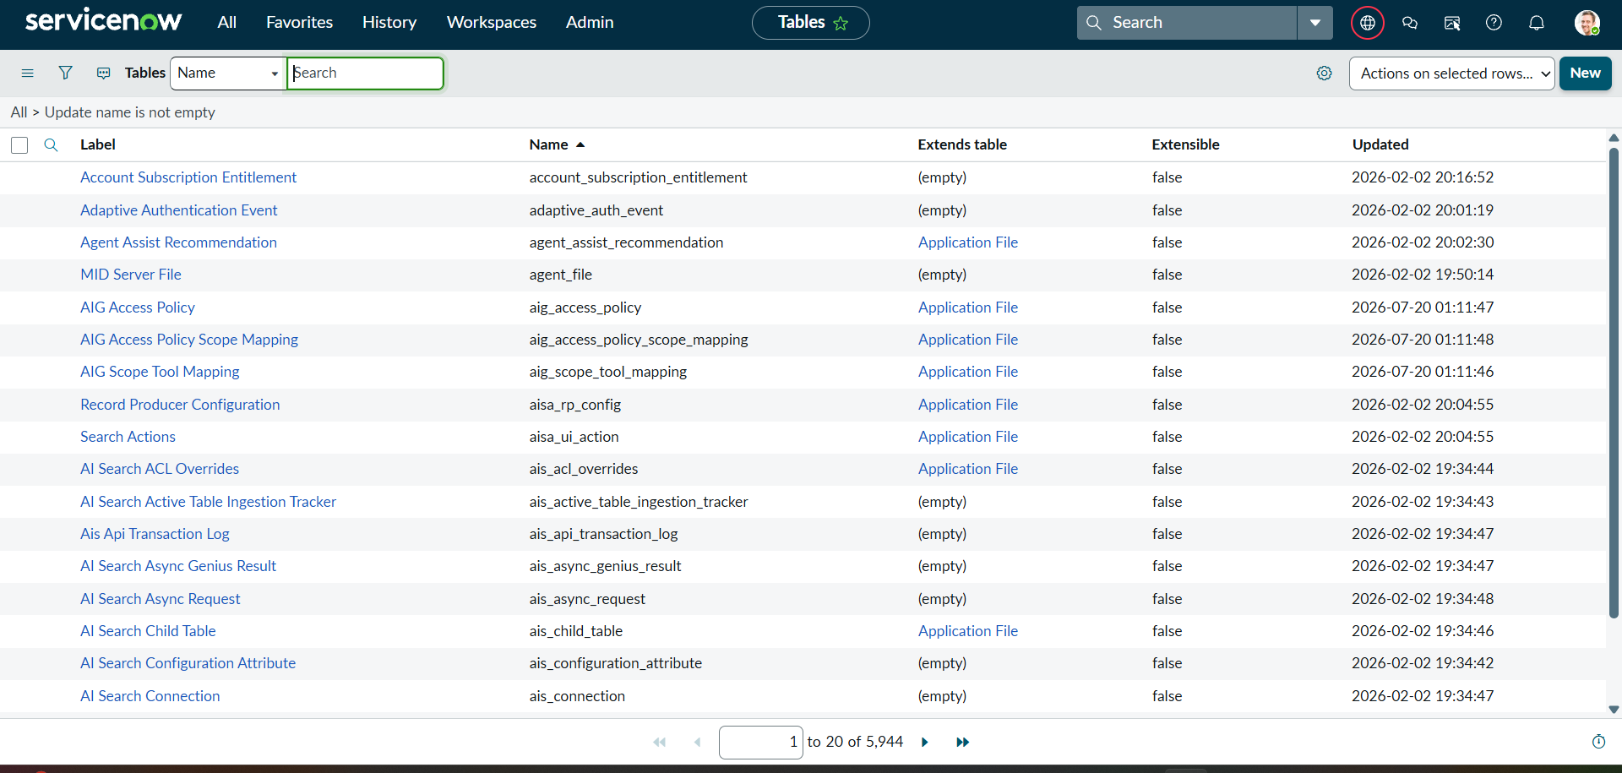

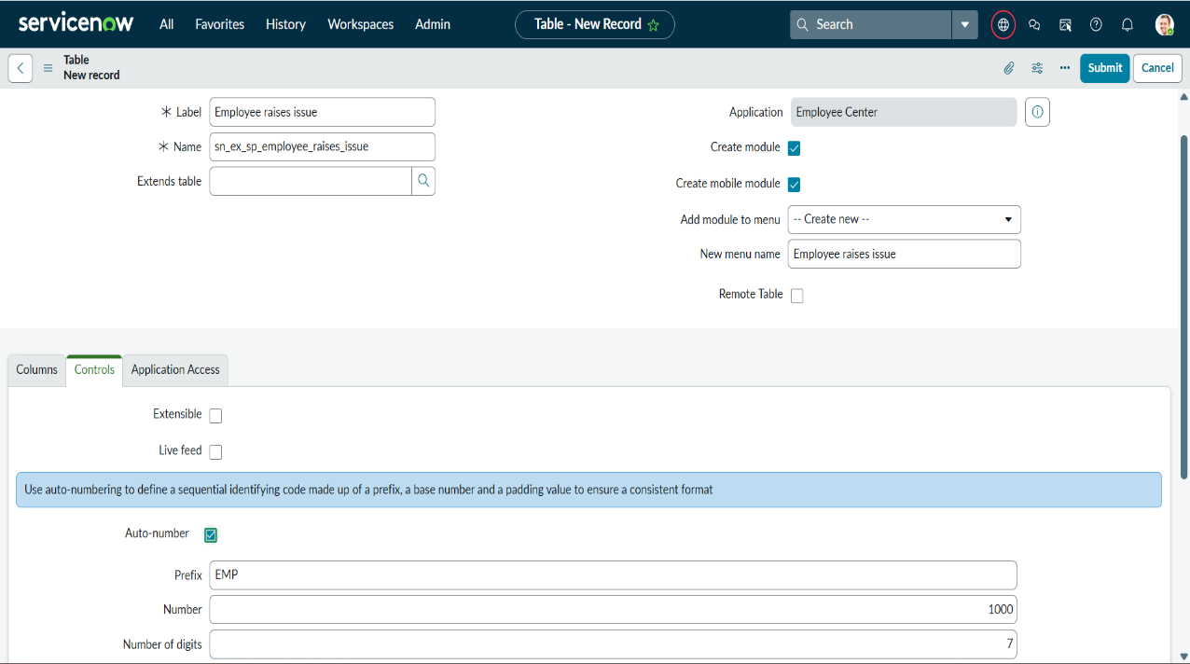

Configure the Create Fields
After creating the Employee Raise Issue table, configure the form fields required to capture employee issue information.
- Under Related Links, click Show Form.
- Open the Context Menu of the form.
- Select Configure → Form Design.
- Create and arrange the required fields with the appropriate names and types.
Field Label | Type | Notes
Number | Auto-Number | Automatically generates a unique issue number.
Requester | Reference | References the sys_user table
Category | Choice | Network. Hardware, Software, Access
Subcategory | Choice | VPN, Laptop, Server, Forgot password
Short Description | String | Provides a brief summary of the employee issue.
Description | String / HTML | Detailed description of the issue.
State | Choice | New, In Progress, Resolved, Closed.
Priority | Choice | Critical, High, Medium, Low.
Assignment Group | Reference | References the sys_user_group table.

5. Save the form after adding all the required fields.
6. Use Form Design to arrange the fields in a logical order so that the form is easy for employees and support teams to use.

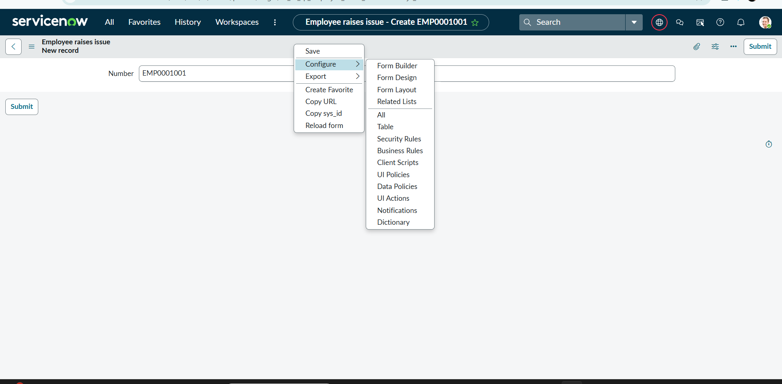

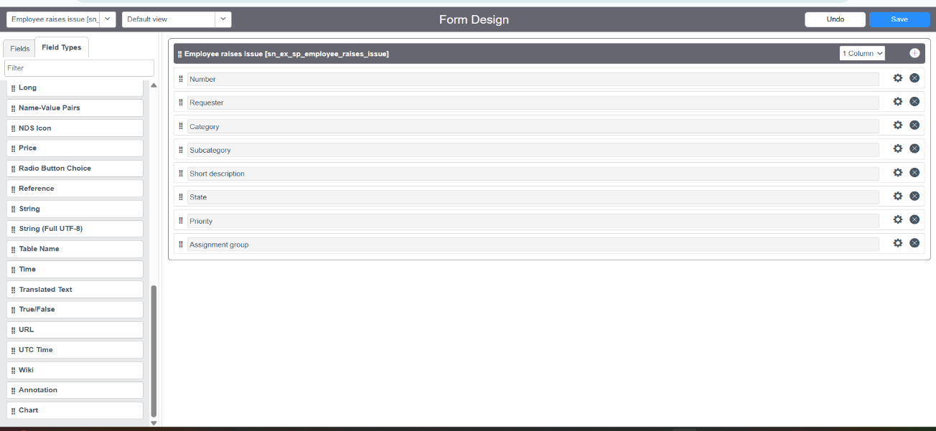
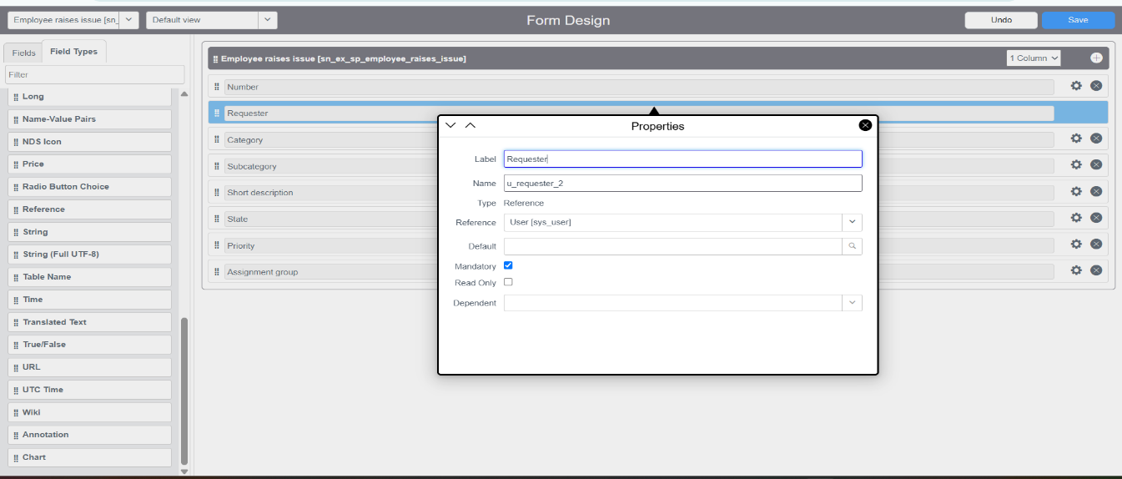

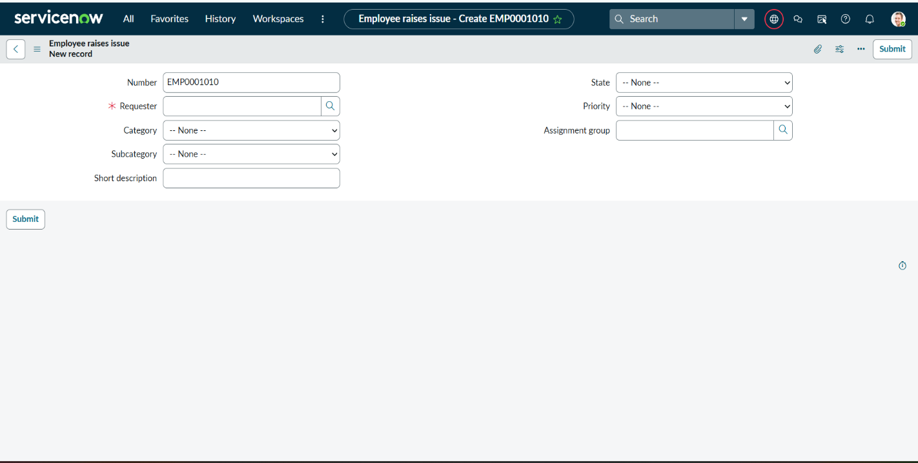
C. Creating UI Policies and Dependency
Configure UI Policies
- Go to All → System UI → UI Policies.
- Click New in the top-right corner.
- Enter the following details:
- Table: Employee Raise Issue
- Short Description: Make Short Description mandatory when the state is New
- Conditions: State is New
- Save the UI Policy.
- Under UI Policy Actions, click New.
- Configure the action:

Field | Value
Field Name | Short Description
Mandatory | True
Visible | Leave alone
Read Only | Leave alone

- Click Submit to save the UI Policy Action.
- Open the Employee Raise Issue form and reload the page.
- Set the State to New and verify that Short Description becomes mandatory

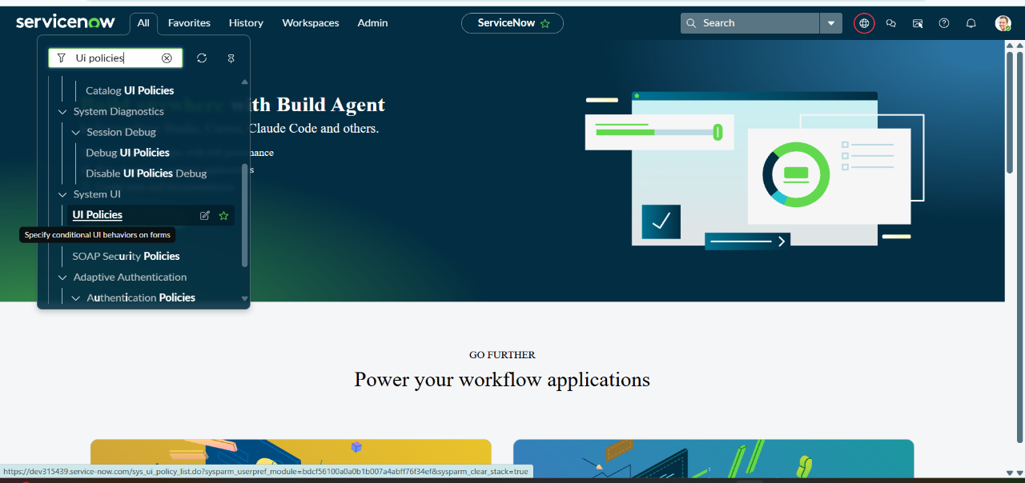

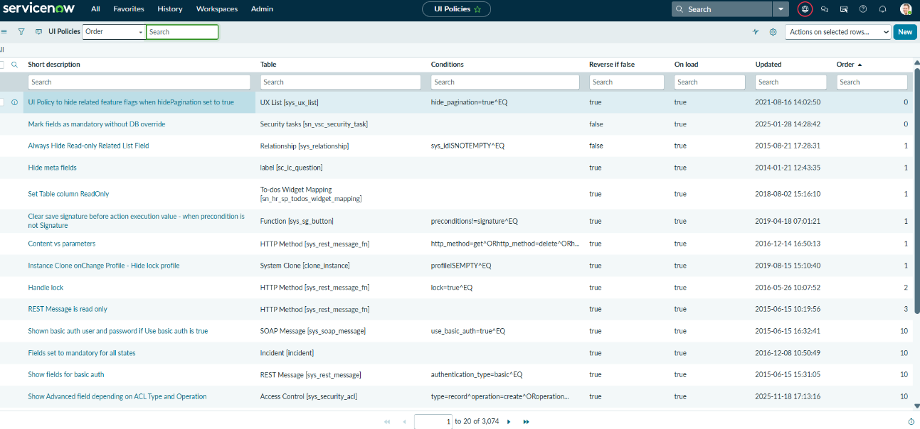

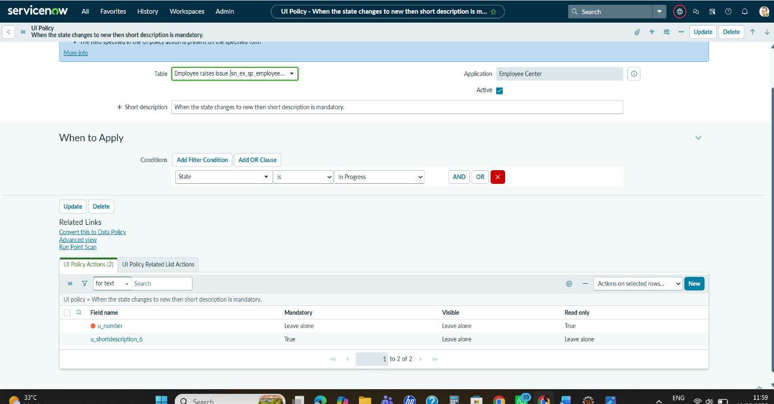

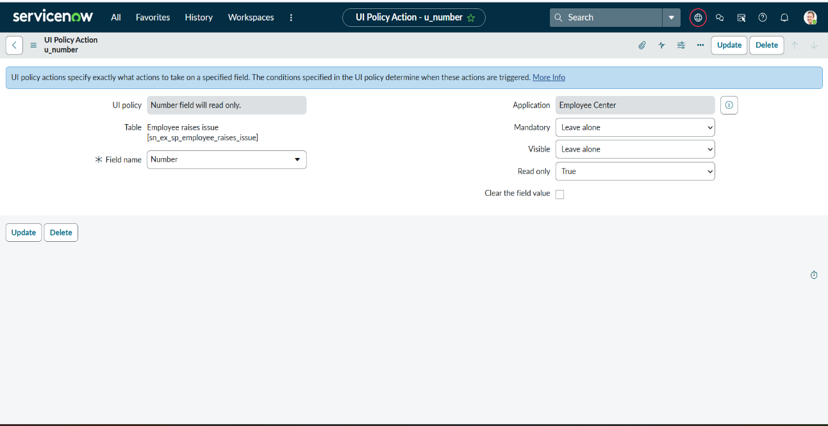
Making Number field Read only
- Navigate to All → System UI → UI Policies.
- Click New in the top-right corner.
- Enter the following details:
- Table: Employee Raise Issue
- Short Description: Number field will be read-only
- Conditions: No filter condition is required.
- Click Submit/Save to create the UI Policy.

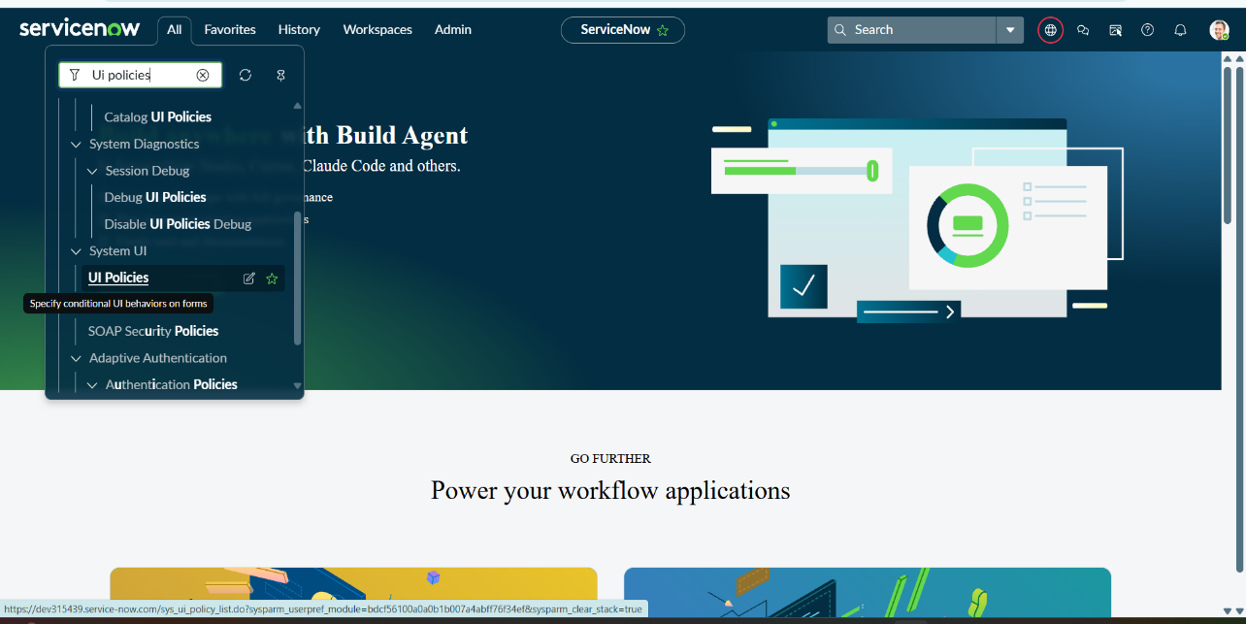

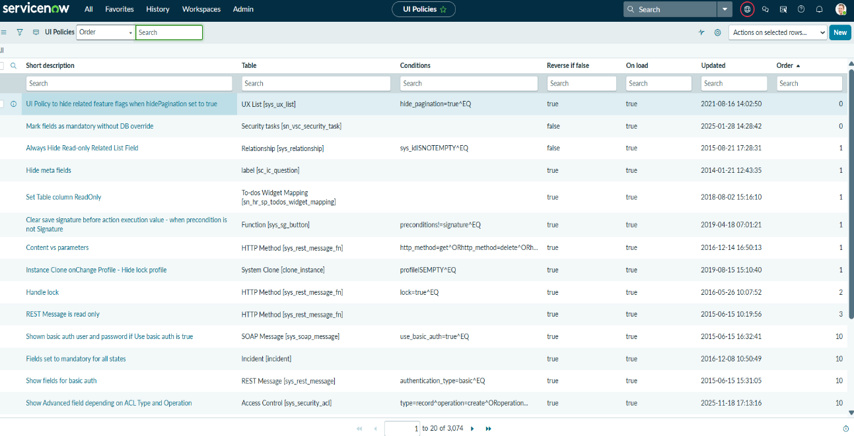
Configure UI Policy Action
- Open the created UI Policy.
- Under the Related Lists, find UI Policy Actions.
- Click New.
- Configure the UI Policy Action as follows:
Field | Value
Field | Number
Read Only | True
Mandatory | Leave as is
Visible | Leave as is

9. Click Submit to save the UI Policy Action.
10.Return to the UI Policy and click Update to save the changes.
Verify the Configuration
11.Open an Employee Raise Issue record.
12.Reload the form.
13.Check the Number field. It should be displayed but should not allow the user to manually modify its value. 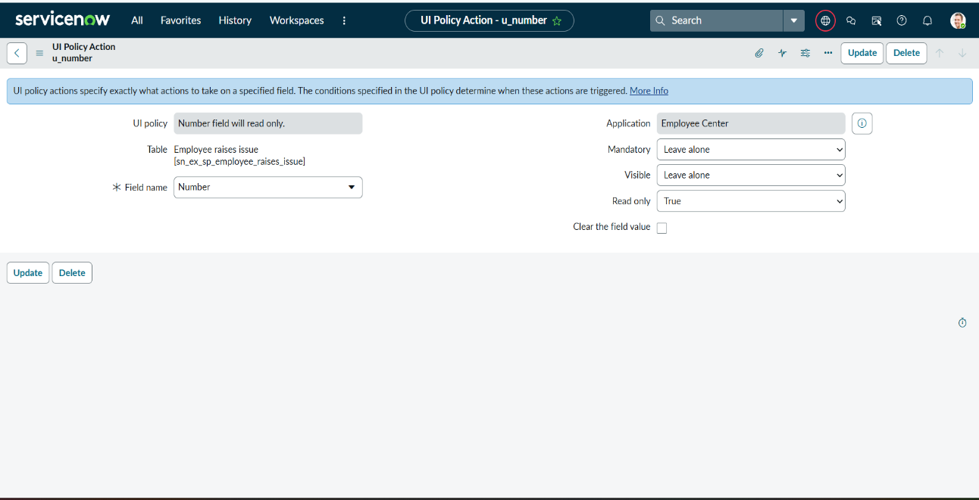

Configure Field Dependency
The Subcategory field is configured as a dependent field of the Category field. This allows the system to display only the relevant subcategory options based on the category selected by the employee.
Steps
- Open the Employee Raise Issue table form.
- Locate the Subcategory field.
- Right-click the Subcategory field and select Configure Dictionary.
- A new Dictionary form will open.
- Select Advanced View from the Related Links section.
- In the Dependent field, enter/select Category.
- Under the Related Lists, open the Choices section.
- Configure the backend Value of each subcategory choice according to the corresponding Category value.
Category | Subcategory
Network | VPN
Hardware | Laptop
Software | Server
Access | Forgot Password
Category and Subcategory Mapping

- Save or update the Dictionary configuration.
10. Open the Employee Raise Issue form and test the configuration.
11. Select a value in the Category field. The Subcategory field will display only the options related to the selected category.

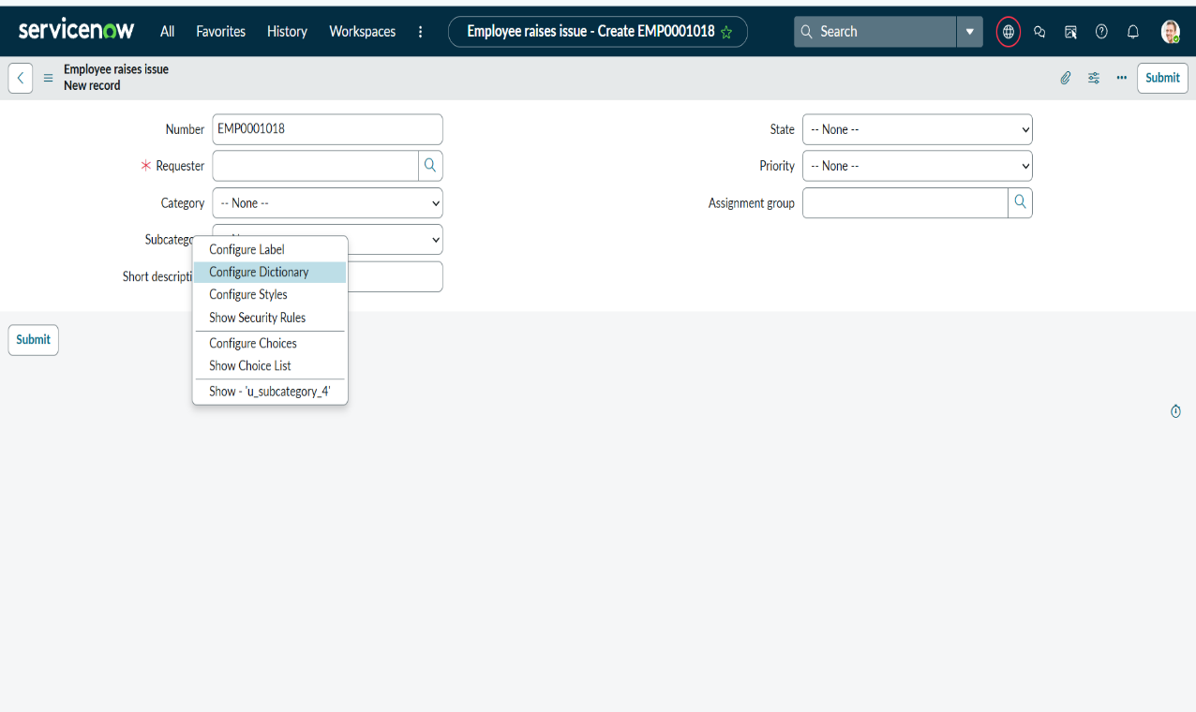
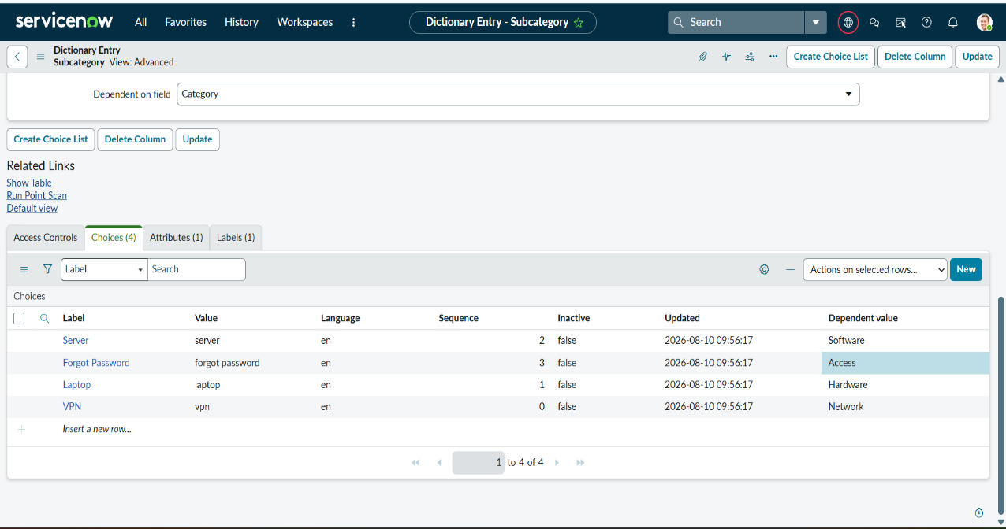

D. Configure a Record Producer
The Record Producer is used to provide employees with a simple form for submitting an issue. When the employee submits the form, ServiceNow creates a new record in the Employee Raise Issue table.
Steps to Create a Record Producer
- Navigate to All → Service Catalog → Catalog Definitions → Record Producers.
- Click the New button in the top-right corner.
- Enter the following details:
- Name: Raise Employee Issue
- Table: Employee Raise Issue
- Description: Allows employees to submit and track workplace issues such as network, software, hardware, and access problems.

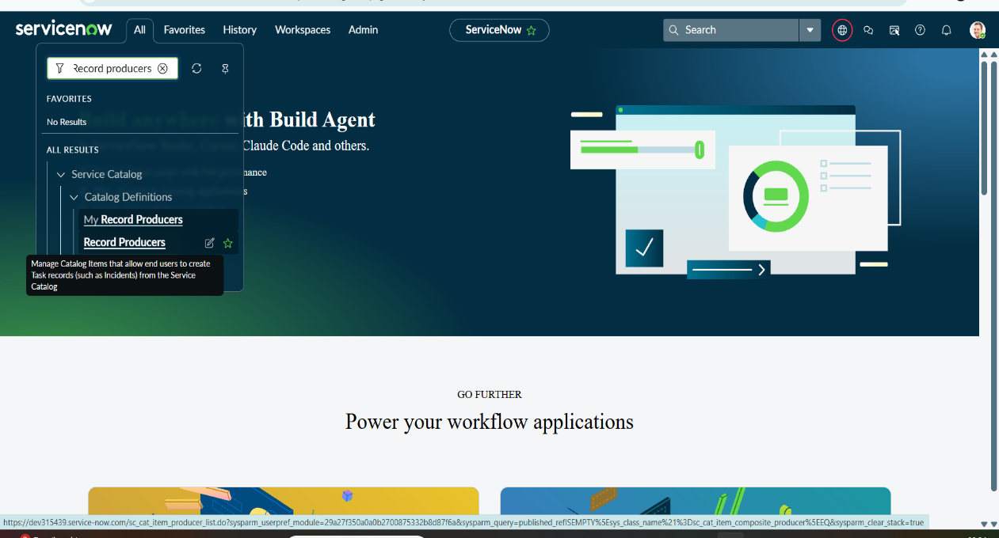

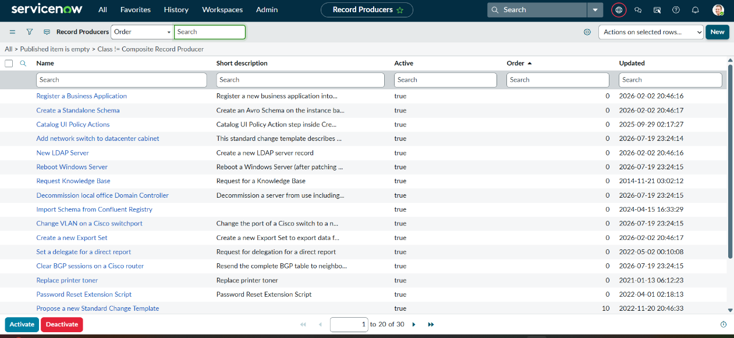

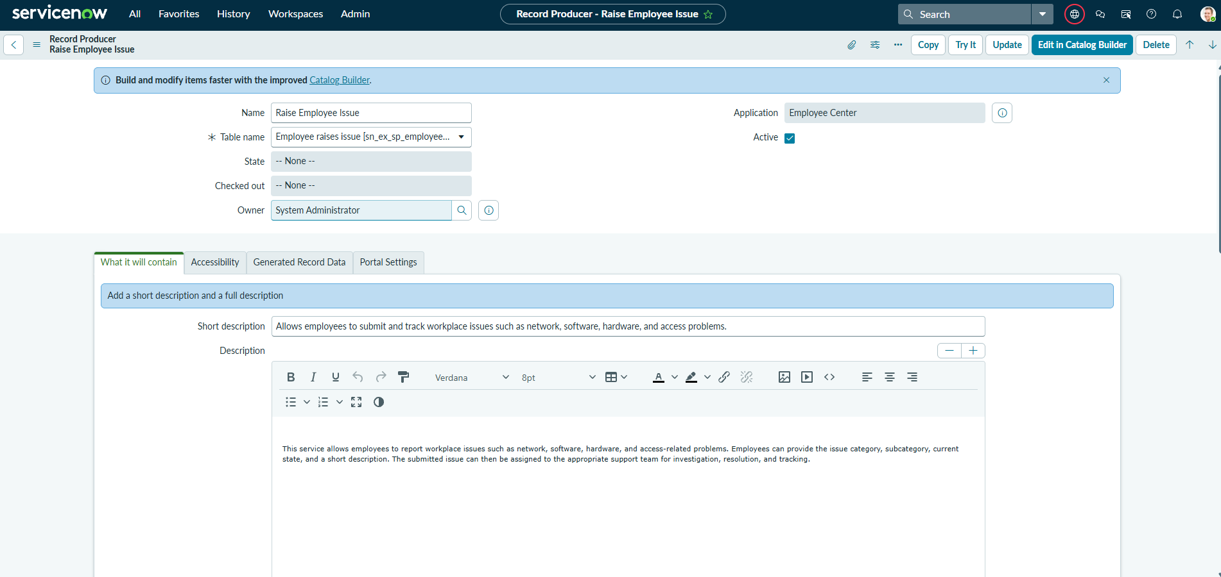
Configure Accessibility
- In the Accessibility section, configure:
- Catalog: Service Catalog
- Category: Service
- Picture: Upload a suitable image for the Employee Raise Issue item.
- Meta: Enter the table name, such as Employee Raise Issue.
- Click Submit/Save to create the Record Producer.
Create Record Producer Variables
- Open the created Raise Employee Issue Record Producer.
- Under the Related Lists, locate the Variables section.
- Click New to create a variable.
- Select the appropriate Type based on the Employee Raise Issue table field.
10. Enable Map to Field.
11. Select the corresponding Field and field type.
12. Assign an Order to each variable, such as 100, 200, 300, 400, and 500.
13. In the Question field, enter the question that should be displayed to the employee. The variable Name will be generated automatically.
Variables
Variable / Question | Type | Notes
What is the Requester? | Reference | Sys_user
Which Category? | Choice | Network, Software, Hardware, Access
What is the Subcategory? | Choice | VPN, Laptop, Server, Forgot Password
Which State is this issue? | Choice | New, In Progress, Resolved, Closed
Short Description | Single line text | String

14.Create all five variables and arrange them in the required order.
15.Click Submit to save each variable.
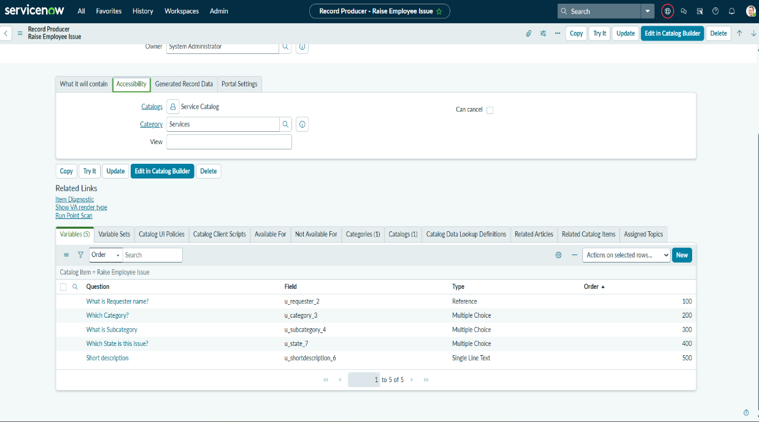
Test the Record Producer in Service Portal
16.Open the ServiceNow instance in a new browser tab.
17. Open the Service Portal by adding /sp to your instance URL.
(https://developer.servicenow.com/sp)
18.In the Service Portal, search for Employee Raise Issue or Raise Employee Issue.
19.Select the Raise Employee Issue item.
20.The Record Producer form will be displayed with the configured variables.
21.Enter the required employee issue details and submit the form.
22.After submission, ServiceNow creates a new record in the Employee Raise Issue table.
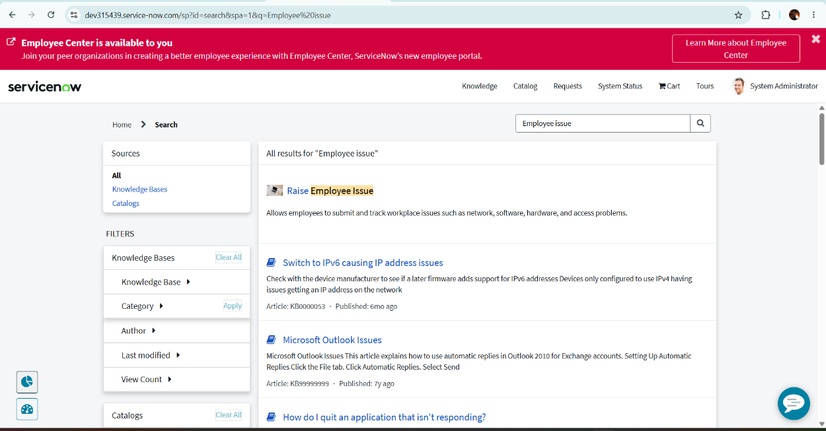

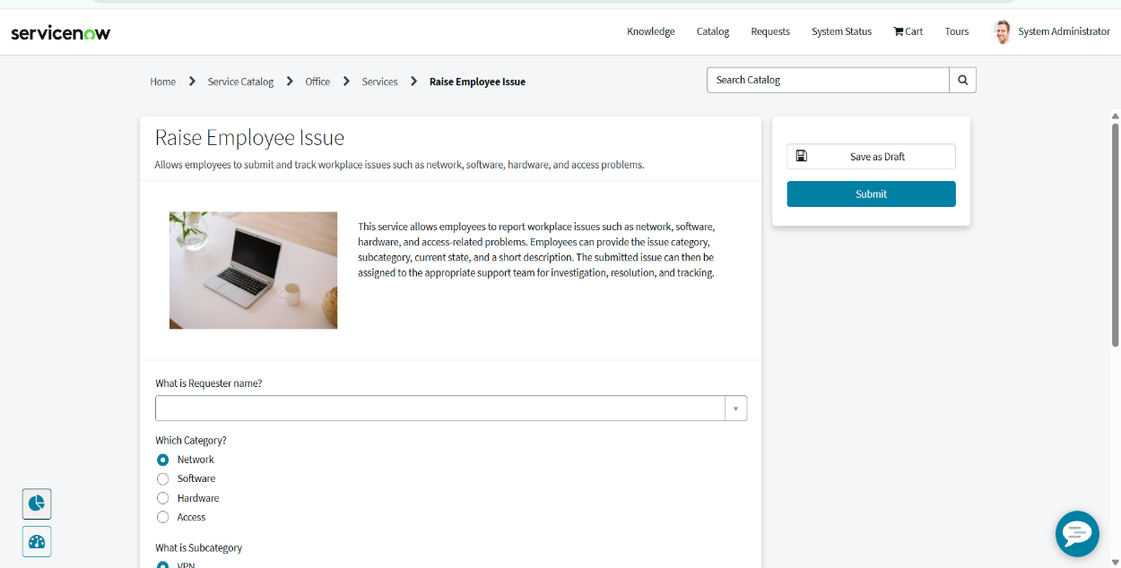
E. Configuring a new Service portal
The Service Portal provides a user-friendly interface where employees can access the Raise Employee Issue Record Producer and submit their workplace issues.
Navigation Steps
- Navigate to All → Service Portal → Service Portal Configuration.
- Select Portals or open Service Portal Configuration and click New to create a new portal.
- Enter the following details:
Field | Value
Title | Employee Raise Issue Portal
URL Suffix | employee_raise_issue
Homepage | ec_standard_home
KB Home Page | esc_knowledge_home
Login Page | login
Logo | Upload Employee Raise Issue logo
Main Menu | Employee Center Menu
404 Page | 404
Theme | Employee Center Coral Theme
- Upload a suitable Employee Raise Issue image in the Logo field.
- Verify that the URL Suffix is unique and does not conflict with an existing portal.
- Click Submit/Save to create the portal.
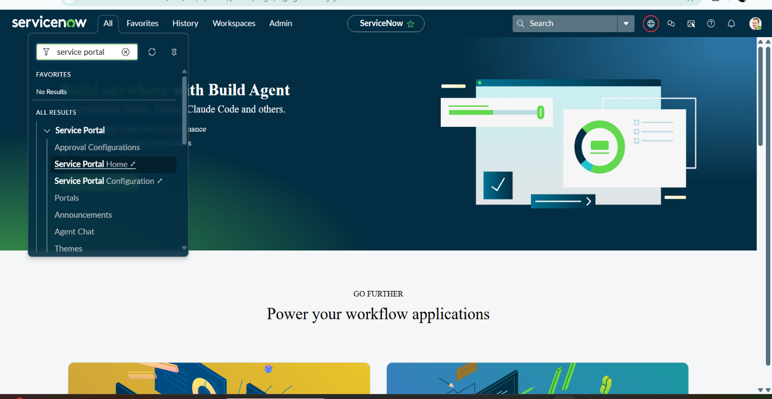
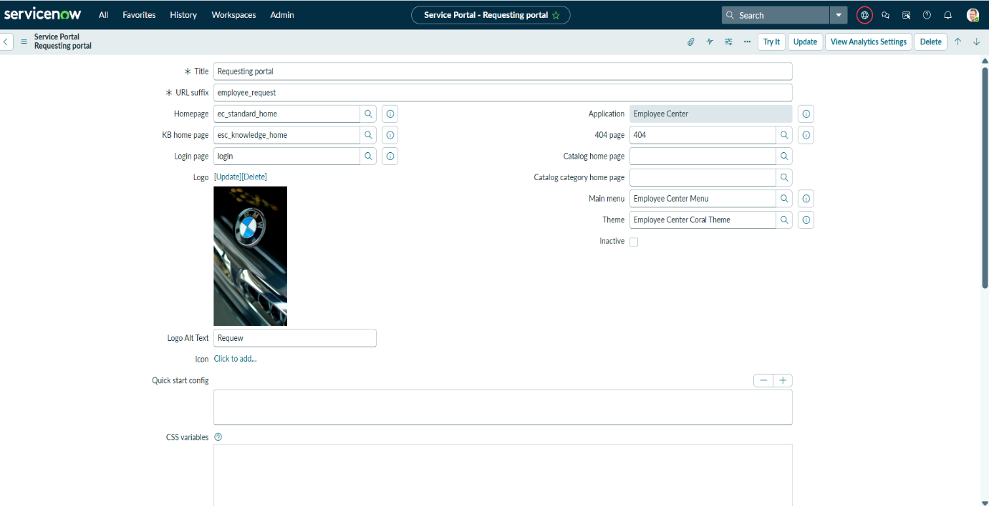

Access the Portal
After creating the portal, open it using the configured URL suffix:
ServiceNow Instance → /sp → Employee Raise Issue Portal
The portal homepage will provide employees with access to the available services and the Raise Employee Issue option.

Configuring A New Employee Center Portal Page
A custom Service Portal page is created to provide employees with a dedicated interface for accessing the Raise Employee Issue functionality.
Navigation Steps
- Navigate to All → Service Portal → Pages.
- Click the New button in the top-right corner to create a new Service Portal page.
- Enter the following details:
- Title: Employee Raise Issue Portal Page
- ID: employee_raise_issue_portal_page
- Open the Context Menu and click Save or Submit.
- After saving, the newly created page will be available in the Service Portal Pages list.
- The page can be further configured by adding appropriate widgets for displaying the Employee Raise Issue functionality.

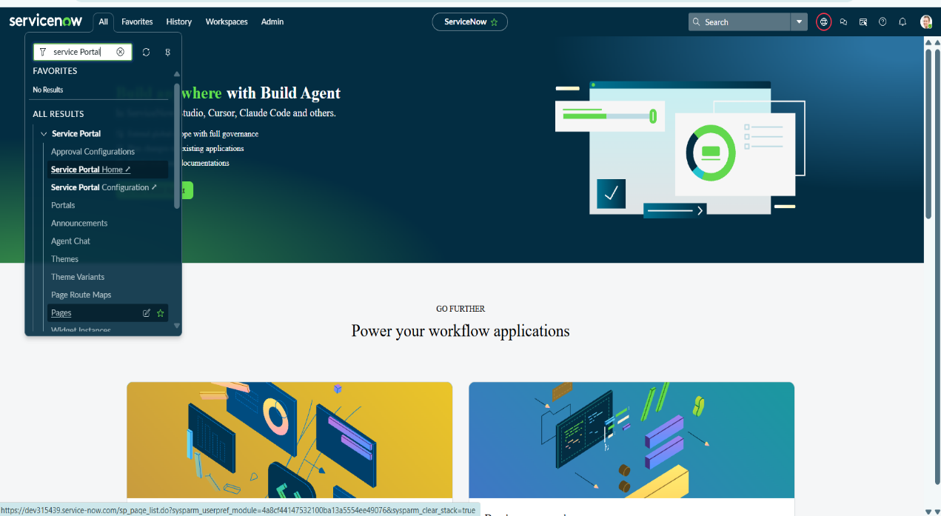
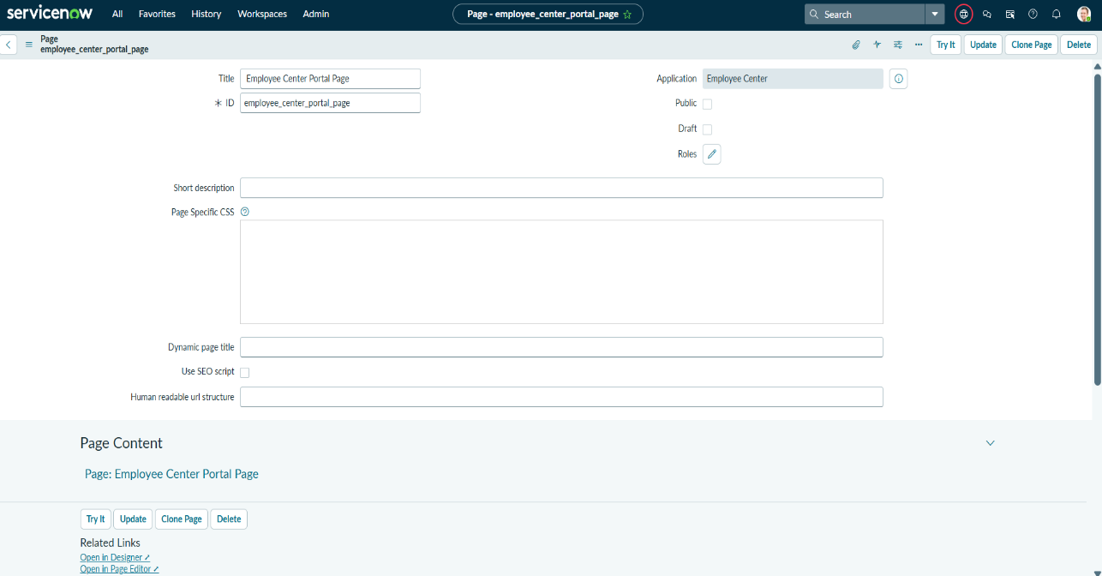
E. Creating Widgets and Adding to the Page
Left Widget Creation
A custom Service Portal widget is created to provide an attractive and interactive interface for the Employee Raise Issue portal. The widget can display information or provide a button that allows employees to access the issue submission form.
Navigation Steps
- Navigate to All → Service Portal → Service Portal Configuration.
- Open Widget Editor.
- Click Create New Widget.
- Enter the widget name: Commercial Widget
- Click Submit to create the widget.
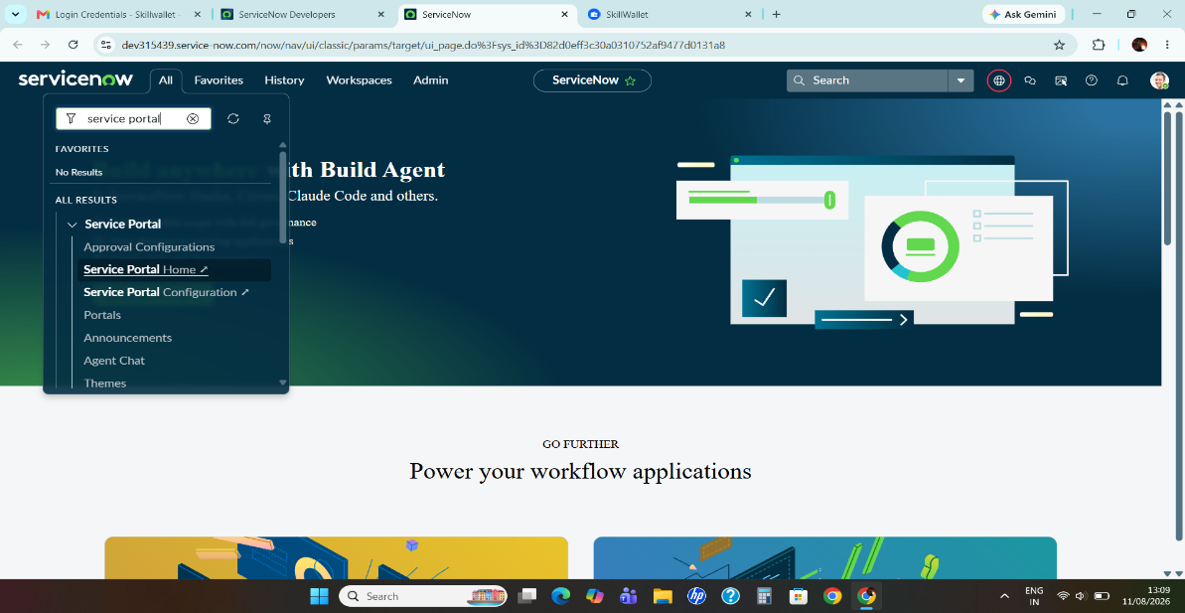

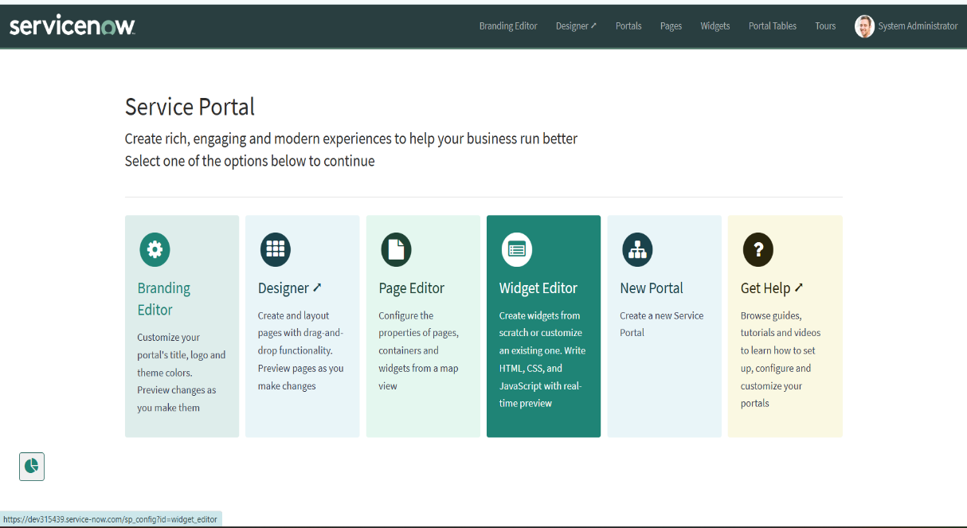
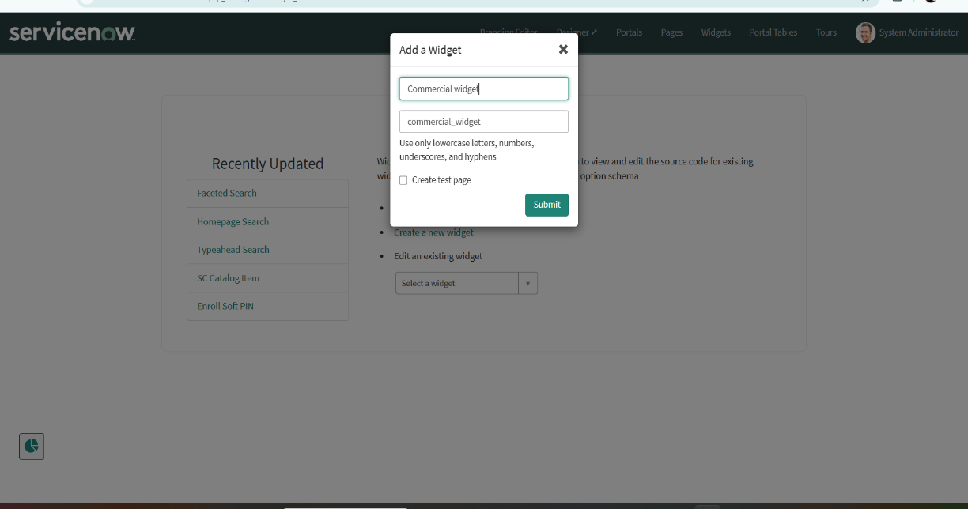
Configure the Widget
- Open the newly created Commercial Widget in the Widget Editor.
- Configure the following sections as required:
- HTML Template – Used to create the structure and content of the widget.
- CSS – Used to control the appearance and layout.
8. Enable the Template option for the sections that you want to use.
9. Use the Eye icon to show or hide the Preview while developing the widget.
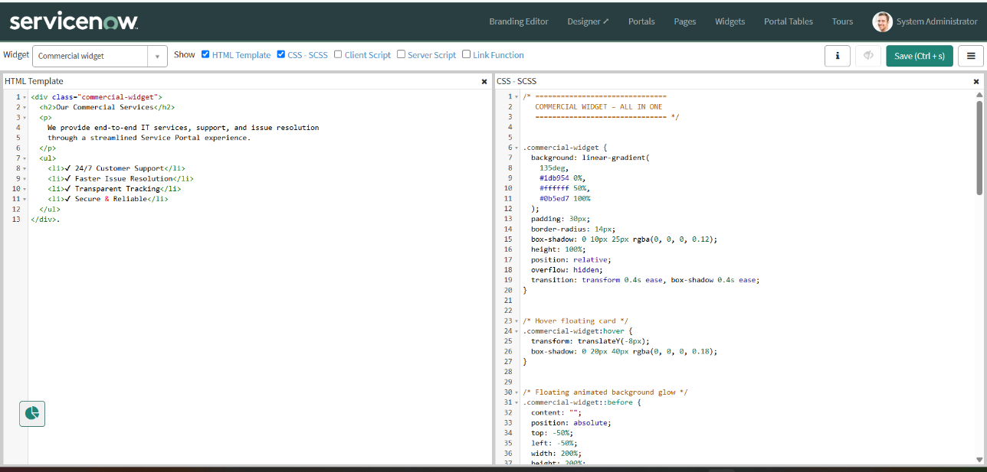

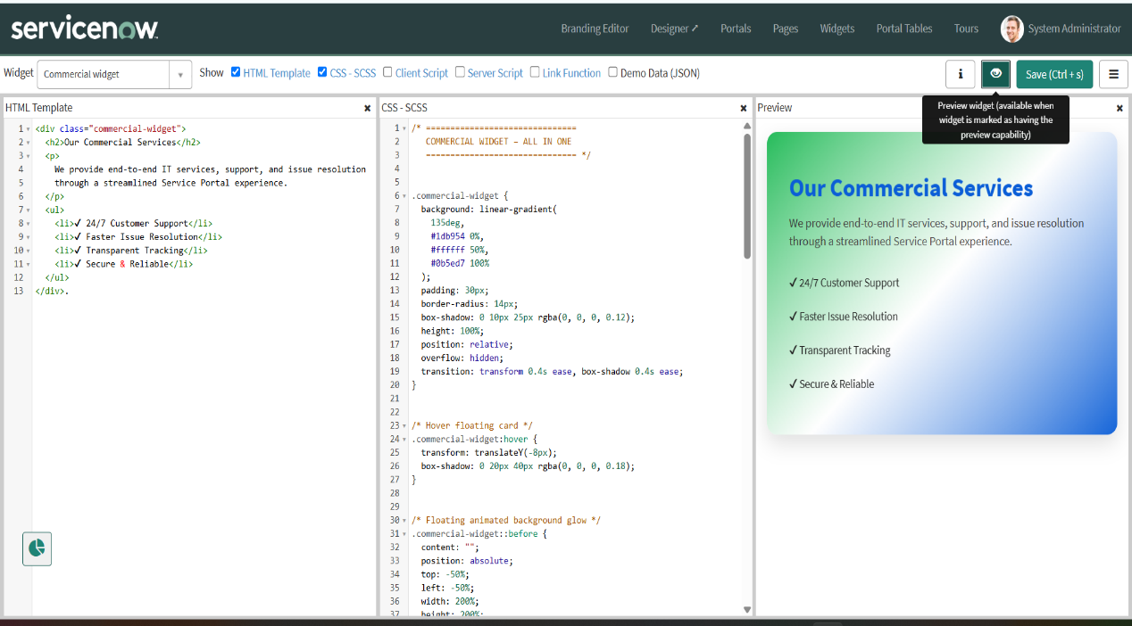
Right Widget Creation
Navigation Steps
- Navigate to All → Service Portal → Service Portal Configuration.
- Open the Widget Editor.
- Click Create New Widget.
- Enter the widget name: Link Redirect
- Click Submit to create the widget.
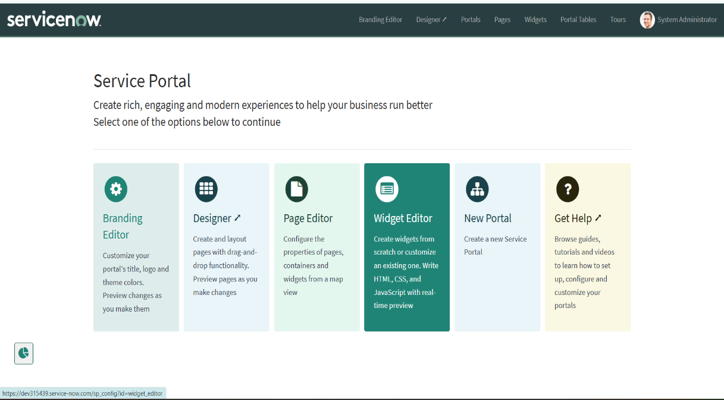

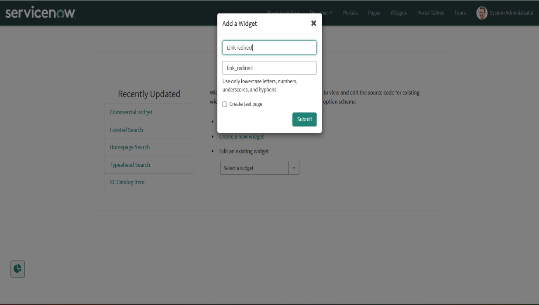
Configure the Widget
- Open the Link Redirect widget in the Widget Editor.
- Enable the required templates for:
- HTML Template
- CSS
- Client Script
- Use the HTML Template to create the link or button that employees can click to raise an issue.
- Use CSS to design the widget and improve its appearance.
10.Use the Client Script to handle the redirection when the employee clicks the button.
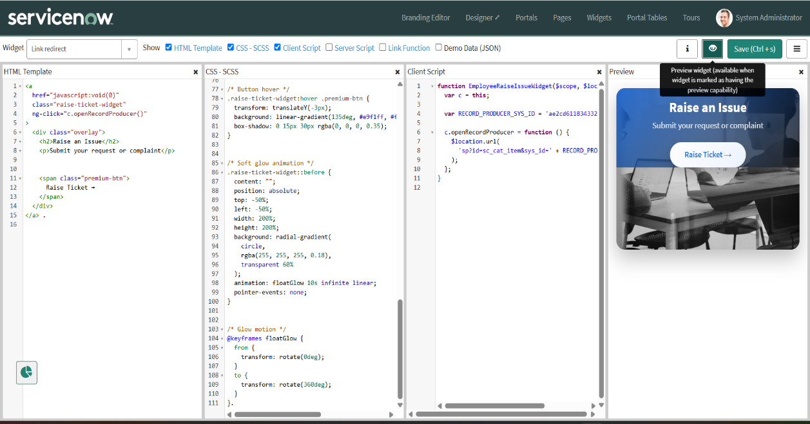

Adding 2 Widgets to the Page
For this project, an existing Employee Center Portal Page is used to display the Employee Raise Issue functionality. The Service Portal Designer is used to arrange containers and widgets on the page.
Navigation Steps
- Use the existing page named Employee Center Portal Page.
- Navigate to All → Service Portal → Service Portal Configuration.
- Open the Service Portal Designer.
- Search for Employee Center Homepage and select the page.
- Open the page in the Designer to modify its layout.

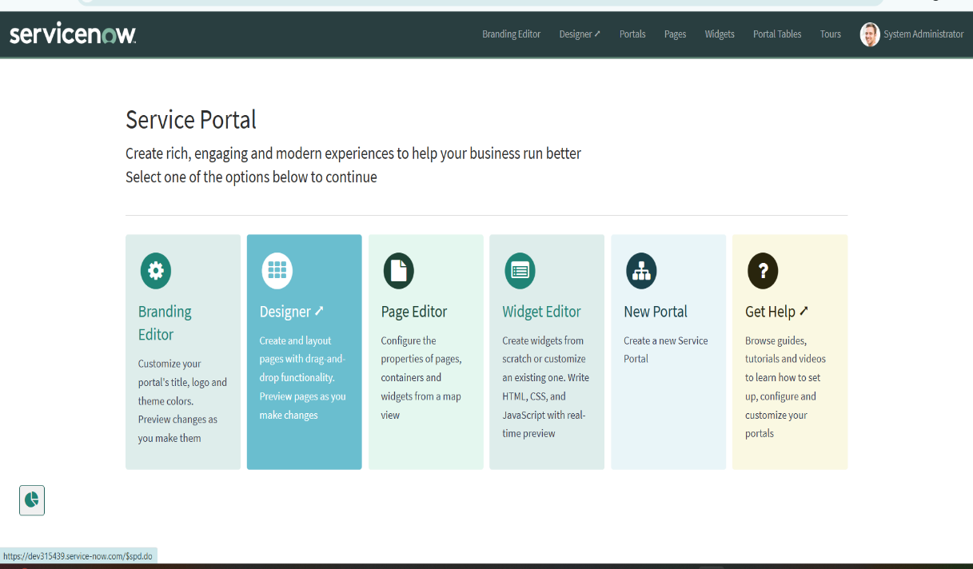

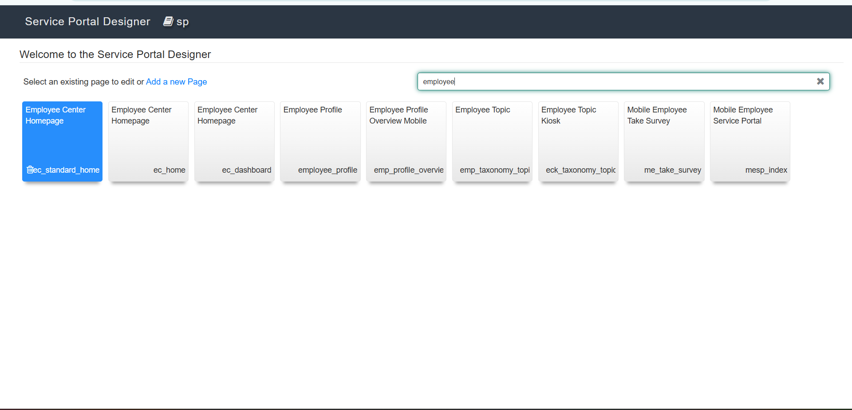

Create Container
- Create a new Container on the page.
- Configure the container layout as 6 × 6 to divide the available space into suitable sections.
- Select the required column or section where the widget needs to be displayed.

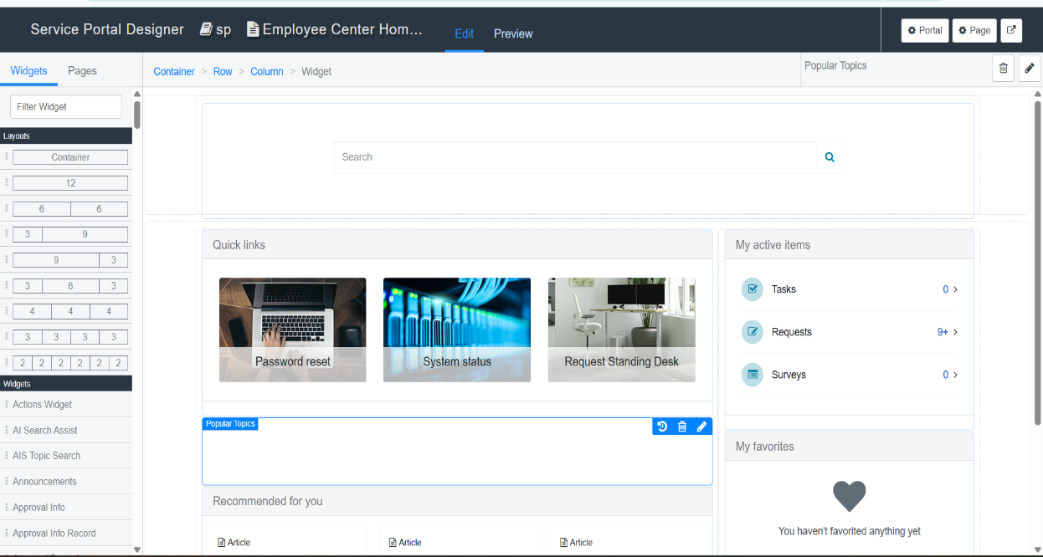
Add Widgets
- Search for the required widgets using the Widget search option.
10. Select the appropriate widget based on the functionality required for the Employee Raise Issue project.
11. Drag and drop the widgets into the required sections of the container.
12. Arrange the widgets according to the desired portal layout.
13. Add the custom Link Redirect widget to provide employees with direct access to the Raise Employee Issue Record Producer.
14. Save the page and preview it to verify the layout and functionality.
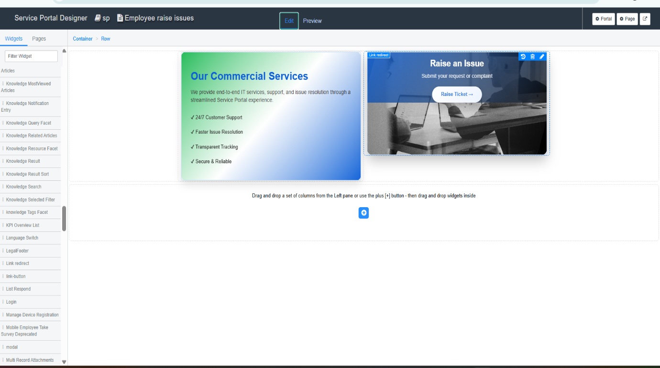
F. Testing and Validation
After completing the Record Producer, Service Portal, widgets, UI Policies, and Dictionary configurations, the application is tested through the Service Portal.
Steps:
- Open a new browser tab.
- Enter the Service Portal URL using the configured portal URL suffix.

- Press Enter to open the Employee Raise Issue Portal.
- Verify that the configured portal logo, images, and icons are displayed correctly.
- Scroll down the page and verify that the created widgets are displayed in the expected locations.
- Move the cursor over the widgets to verify the floating text and interactive effects.
- Click the Raise an Issue / Link button.
- Verify that the button redirects to the Raise Employee Issue Record Producer.
- Enter the required employee and issue details, such as:
  - Requester
  - Category
  - Subcategory
  - State
  - Short Description
- Click the Submit button.
10.Verify that the submitted information creates a new record in the Employee Raise Issue table.
11.Check the Number field and confirm that the issue number is automatically generated.
12.Change the State to New and verify that Short Description becomes mandatory according to the UI Policy.
13.Verify that the Number field is read-only and cannot be manually modified.
14.Verify the Category and Subcategory dependency.
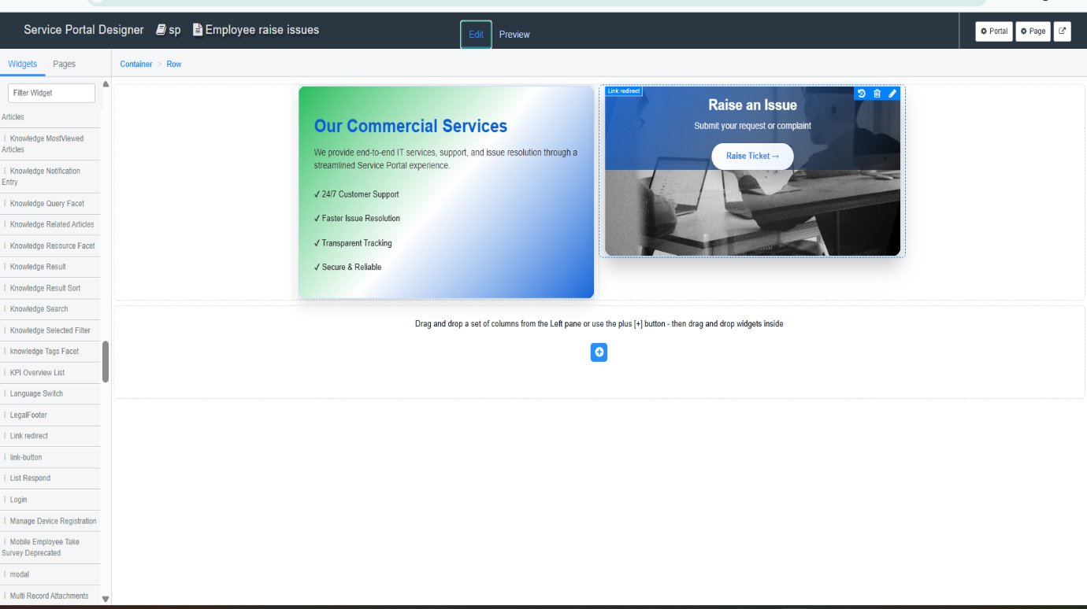
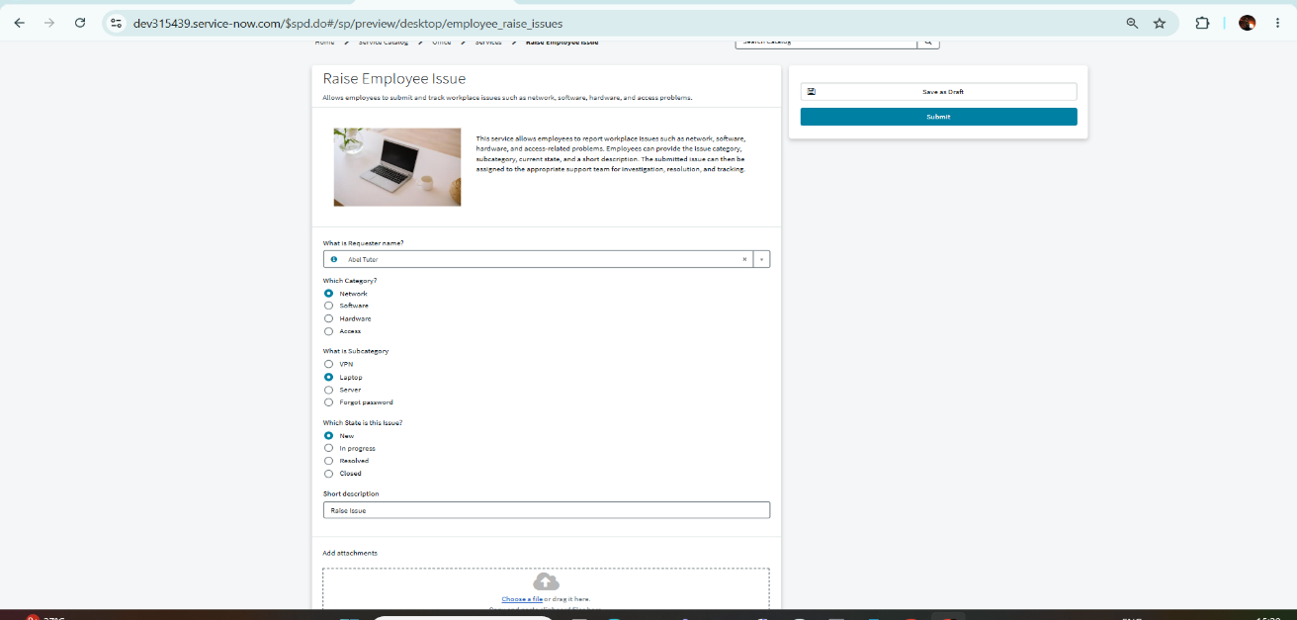
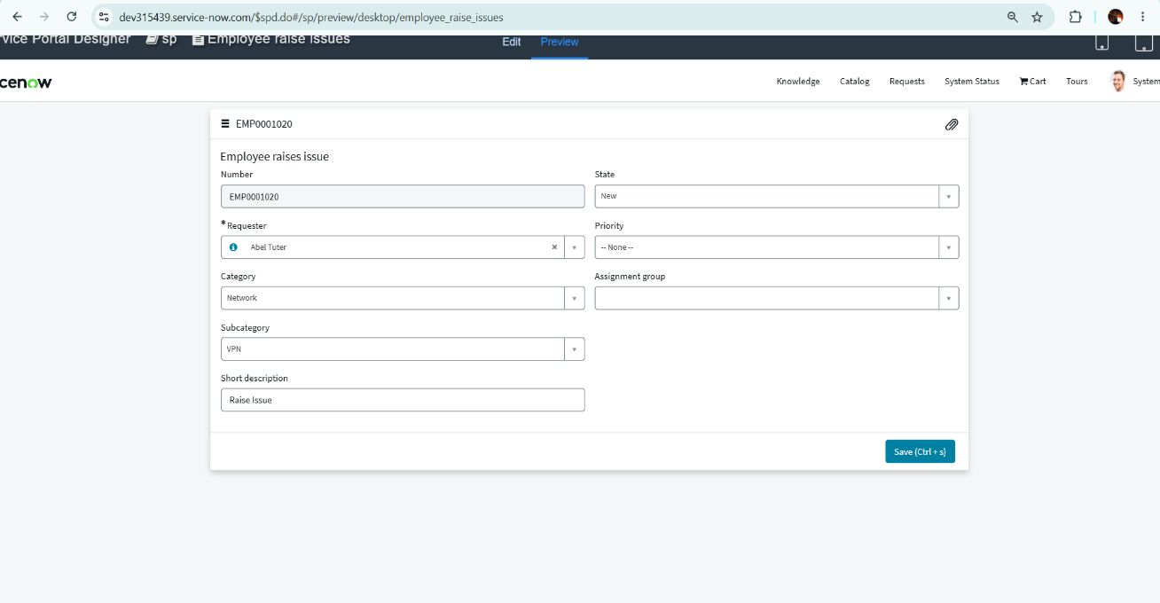
7.Conclusion
The Employee Raise Issues Management System was successfully developed using the ServiceNow platform to provide employees with an easy and organized way to report workplace issues. The system uses a Record Producer and Service Portal to simplify issue submission and automatically create records in the Employee Raise Issue table.
Features:
- Provides an easy platform for employees to raise workplace issues.
- Allows employees to submit issue details through the Service Portal.
- Automatically creates an issue record using a Record Producer.
- Provides unique issue numbers for easy identification.
- Helps categorize issues using Category and Subcategory fields.
- Allows employees and managers to track issue status.

